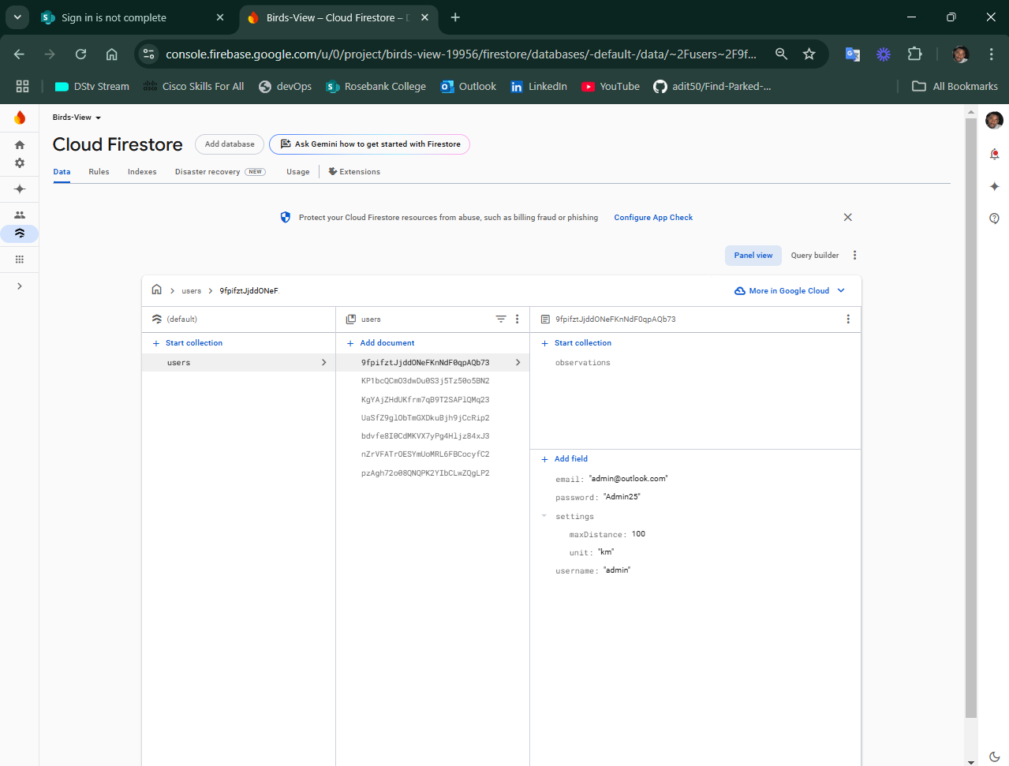
Cloud Firestore: User Settings & Observations are stored on the Cloud Firestore.

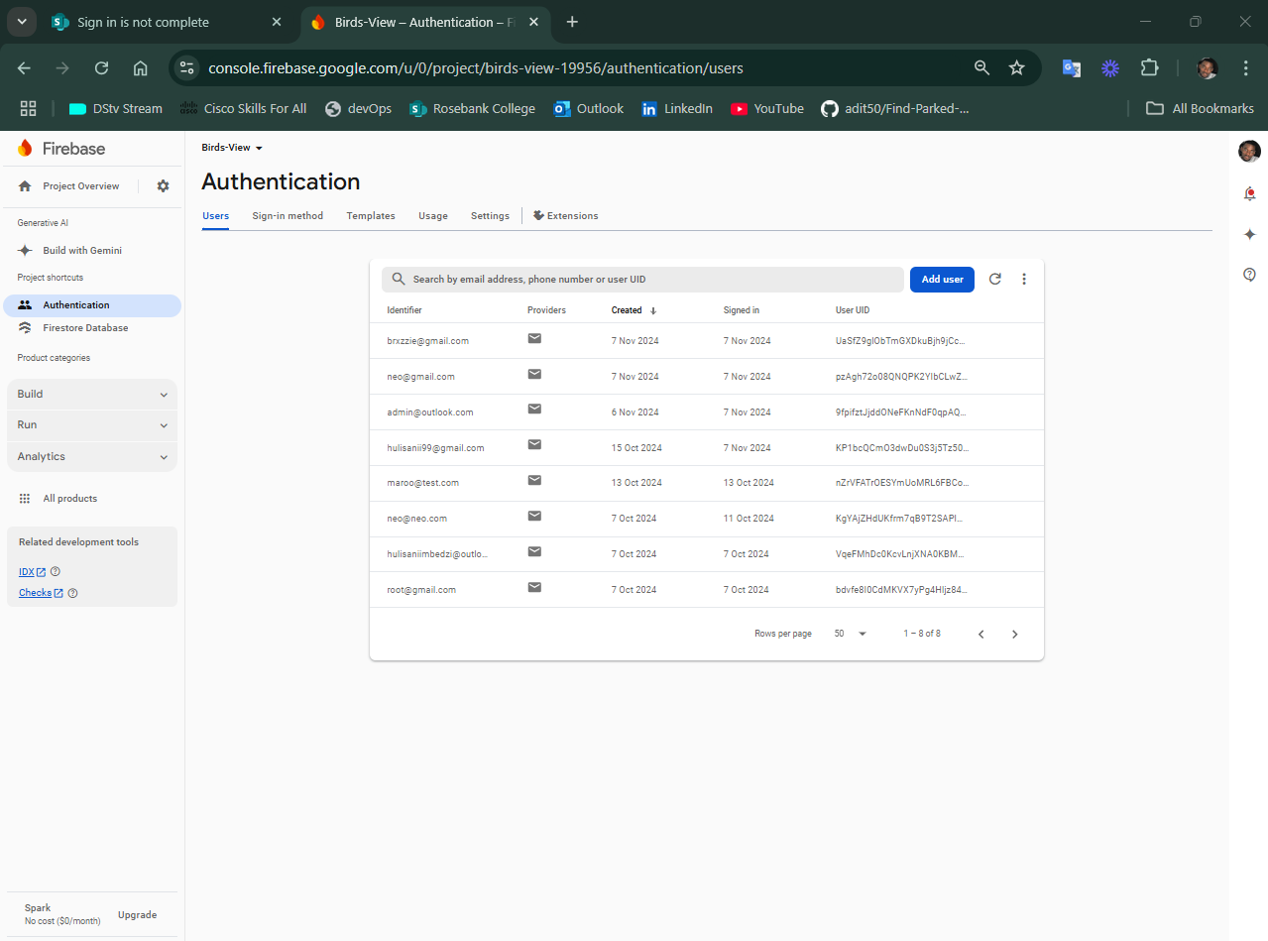
Firebase Authentication: Registered User Accounts

Added Feature:
Added a new Leaderboard Page for users to view the progress of themselves and other users. User with the most Observations will be at First place on the Leaderboard.
